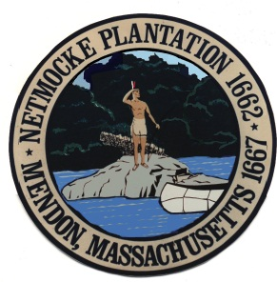
TOWN CLERK STAMP:

TOWN OF MENDON
NOTICE OF MEETING

BOARD/COMMITTEE NAME:
MENDON FINANCE COMMITTEE
DATE OF MEETING: Monday, May 17, 2021
TIME OF MEETING: 7:00PM
LOCATION OF MEETING: Mendon Town Hall
Remote Meeting
AGENDA
- Call to order
- Review and approve Fin Com Minutes
- Attend Town of Mendon Master Plan Steering Committee Meeting
- Other items not reasonably anticipated by the Chairman 48 hours in advance

